Topic:
CD fluidics technologies for healthcare applications
CD fluidics for addressing environmental challenges
Centrifugal microfluidic platforms for cell and particle manipulation
Novel centrifugal microfluidic technologies (others)

Preferred session: Abstract Ref No: CD 00
Oral
Poster
No preference

1st International Centripetal Micro Fluidics Conference Template and Instructions for Abstract Preparation

Presenter full name¹, and co-author A¹ and co-author B²
¹School of Engineering and Science, Tec de Monterrey, Monterrey, Mexico
²Henry Samueli School of Engineering, University of California, Irvine, USA

We cordially invite authors to submit original presentations on advancements in centripetal microfluidics, focusing on environmental sciences, molecular diagnostics, and innovative platforms. When crafting your abstract, it's paramount to state your primary results and novelties in the opening sentences. Delve into the specifics: how does your work deviate from prior works, both from your own group and others? Highlighting differences from research presented at other international meetings can be particularly beneficial.
After introducing the core concepts and relating your work to existing literature, offer a detailed breakdown of your methods, device structures, and specific results, be they experimental or theoretical. Figures can bolster these results, but ensure they are clear and discernible.
Lastly, when submitting your abstract, indicate your preferred presentation format. However, owing to the limitations on the number of oral presentations, not all preferences might be accommodated. Post-submission, you'll receive an acceptance letter detailing the session assigned to you.
We believe in the transformative power of shared knowledge and innovation and eagerly anticipate your valuable contributions.
To uphold the integrity and quality of our conference, we have outlined detailed submission guidelines below:
- Submissions should be channeled exclusively through ConfTool.
- Your submission should primarily comprise an Extended Abstract. This is a 2-page document that details your work. It's essential to strictly adhere to the provided templates when crafting this document.
- Begin your extended abstract with an Executive Summary. This is a crisp, 200-word overview of your work. Ensure this summary is free from any author-specific details, as it will serve to represent your work in the table of contents.
- Accompanying your executive summary, provide a Graphical Abstract. This should be a clear, representative image of your work. Ensure the image is in JPG format, with a maximum file size of 3MB.
- Ensure your document has undergone a comprehensive spell-check.
- All figures, tables, and charts should be numbered meticulously. Remember to place captions below figures and above tables. Ensure figures are of electronic quality. Ideally, they should be in TIFF or EPS format, with a minimum resolution of 300 dpi.
- Finally, convert your entire document into a PDF format. Any non-standard fonts should be embedded within this PDF. Ensure the final file does not exceed 2MB in size. Word Count: 368



Figure 1: Conceptional sketch in 300 dpi

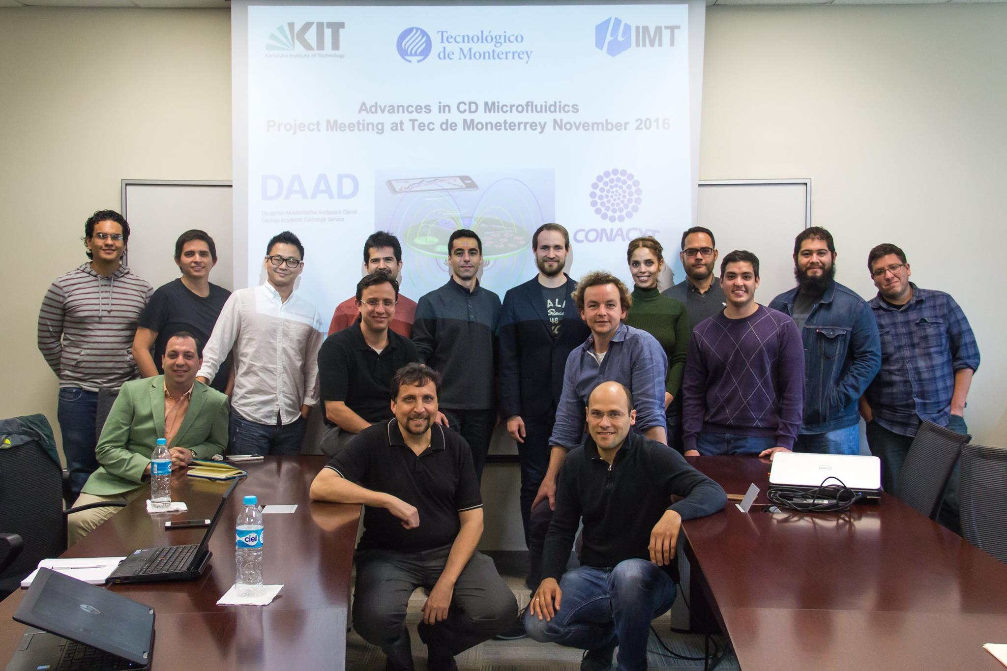

Figure 2: Photograph of the chip xxx in 300 dpi

Table 1. Example of a table
Table Head | Table Column Head
 | Table Column Subhead | Subhead | Subhead
Copy | More table copy

REFERENCES

- APA format.

